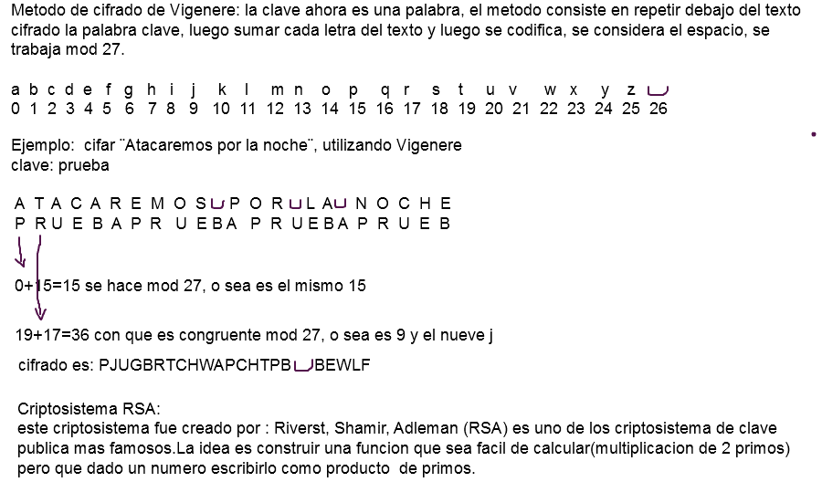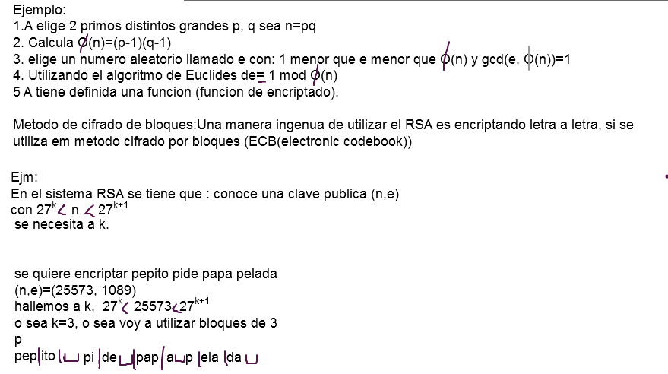

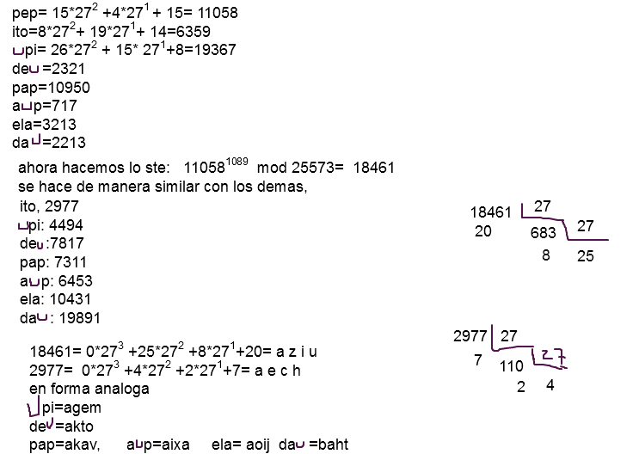

P=89, q=97, n=89*97= 8633, φ((8633)=88*96=8448 , e=19, 1<e<8448, gcd(e, 8448)=1
Clave: publica (n,e)=(8633, 19), alfabeto mod 27
Mensaje: examen de discretas
27^{k} < 8633 <27^{k+1}, K=2
ex | am | en | __d | e__ | di | sc | re | ta | S_
4*27 +23=131 | 0*27+12=12 | 4*27+13=121 | 26*27+3=705 | 4*27+26=134 | 3*27+8=  89 | 18*27+2=  488 | 17*27+4=463 | 19*27=513 | 18*27+26=512

131¹⁹ mod 8633 | 1533 | 2 2 21 | c c v
12¹⁹ mod 8633 | 1728 | 2 10 0 | c k a
121¹⁹ mod 8633 | 4311 | 5 24 18 | f y s
705¹⁹ mod 8633 | 208 | 0 7 19 | a h t
134¹⁹ mod 8633 | 5437 | 7 12 10 | hmk
89¹⁹ mod 8633 | 5696 | 7 21 26 | hv_
488¹⁹ mod 8633 | 1259 | 1 19 17 | btr
463¹⁹ mod 8633 | 1477 | 2 0 19 | cat
513¹⁹ mod 8633 | 552 | 0 20 12 | aum
512¹⁹ mod 8633 | 865 | 1 5 1 | bfb

1533 I_27_
21 56 I_27_
2 2

